Physical changes in the environment
Purpose | Identify and predict the effects of changes in physical conditions on the living things in an environment using evidence, and describe actions to address the impact of these changes.
Scenario | This pond sits beside a school and is cared for by the Year 6 class. Recently a new building development has begun next to the pond.  Over the past six months since the building began, the Year 6 class has noticed more rubbish and waste materials in and around the pond.
Tasks | - Identify an environmental change that has occurred to the pond because of the recent building development.
 | - Predict the effect the building development will have on the organisms in the pond.
 | - Graph the number of frog eggs counted in the pond during the building development and suggest reasons for the change in numbers of frog eggs.
 | - Describe actions that the class may take to minimise the impact of the building development on the pond environment.

Below is a picture of the pond before the development commenced.
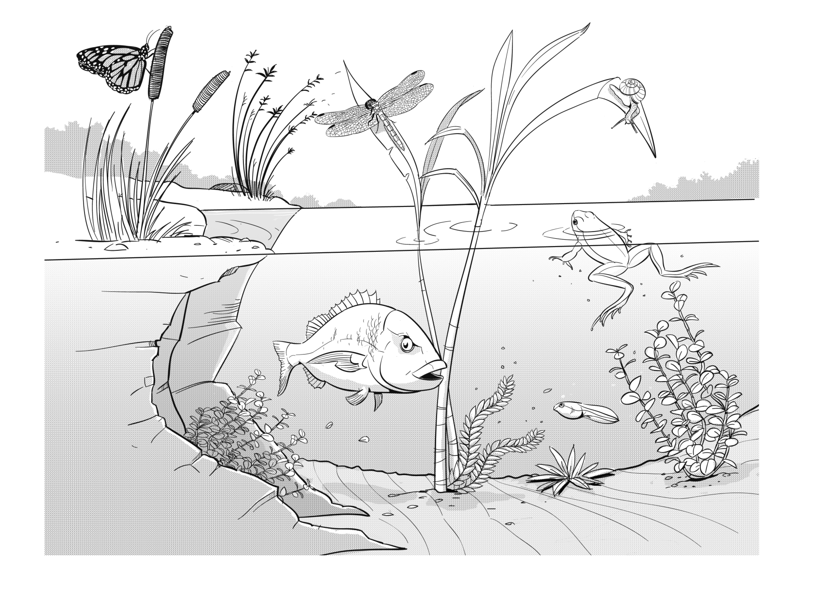
- Identify a major environmental change that may occur to the pond as a result of the building development.
- a) Predict three (3) ways this change will affect the ponds ecosystem.

b) Choose one living thing pictured in the ecosystem and explain how this environmental change will affect the growth and survival of the organism.
- The Year 6 class has been collecting and collating data on frog’s eggs for a number of years. In previous years the number of eggs has not fallen below 60. The following table contains the data they have collected this year.
Month | Number of eggs counted
January | 100
February | 90
March | 80
April | 40
May | 20
June | 10

a) Draw a column graph to represent the population of frog’s eggs from when the development started in January to June.

b) Explain the change in the pond ecosystem using the data collected.
Frog’s eggs in the pond

Number of eggs

Jan Feb Mar Apr May June

Time in months
4. a) What actions could be put in place by the Year 6 class to minimise the impact of the
development on the environmental health of the pond?

b) Explain why these actions would be effective.
- Explain how the Year 6 class would know if the actions taken were successful.

